


West Coast Collaborative
Specialist Mathematics Units 3 & 4
Test 3 2018
Calculator Free Section
Name: __________________________ Score: _____ / 22
Time Allowed: 22 minutes
No calculators or notes are to be used.
Access to approved Mathematics Specialist formulae sheet is permitted.
Where a question or part of a question is worth more than 2 marks sufficient working to justify your solution is required.
1. [ 4 marks ]
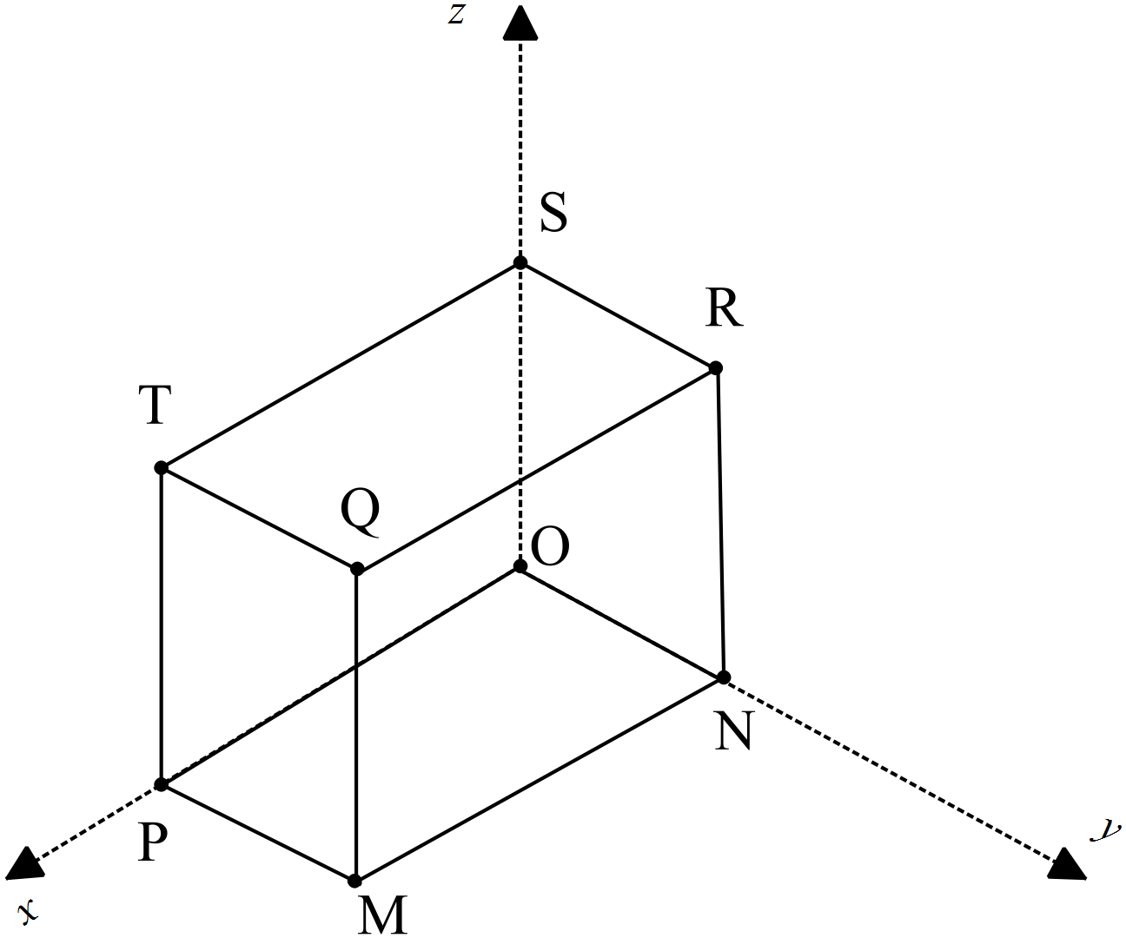MNOPQRST is a rectangular prism with OP = p, ON = n and OS = s.
O is the origin of the x-y-z axes.
Use the fact that $a×b=\left|a\right|\left|b\right|sinθ$ and $a.b= \left|a\right|\left|b\right|cosθ$to prove that the volume of the cuboid is $\left|\left(p×n\right).s\right|$

2. [ 5,1 = 6 marks]
A plane Γ contains the points P at position k – 2j, Q at 4i + j +3k and R at 2k – i.
a) Determine a vector equation which contains the normal to the plane.

b) Express this as a Cartesian equation.

3. [1, 1, 3 = 5 marks ]
A point P moves in a path according to the parametric equations: $x=2\cos{t}, y=3\sin{t , }$ where $t≥0$
- State the Cartesian equation of the path

- State the velocity vector of the ellipse

- Draw the path traced by P on the graph, indicating its direction and key points clearly.
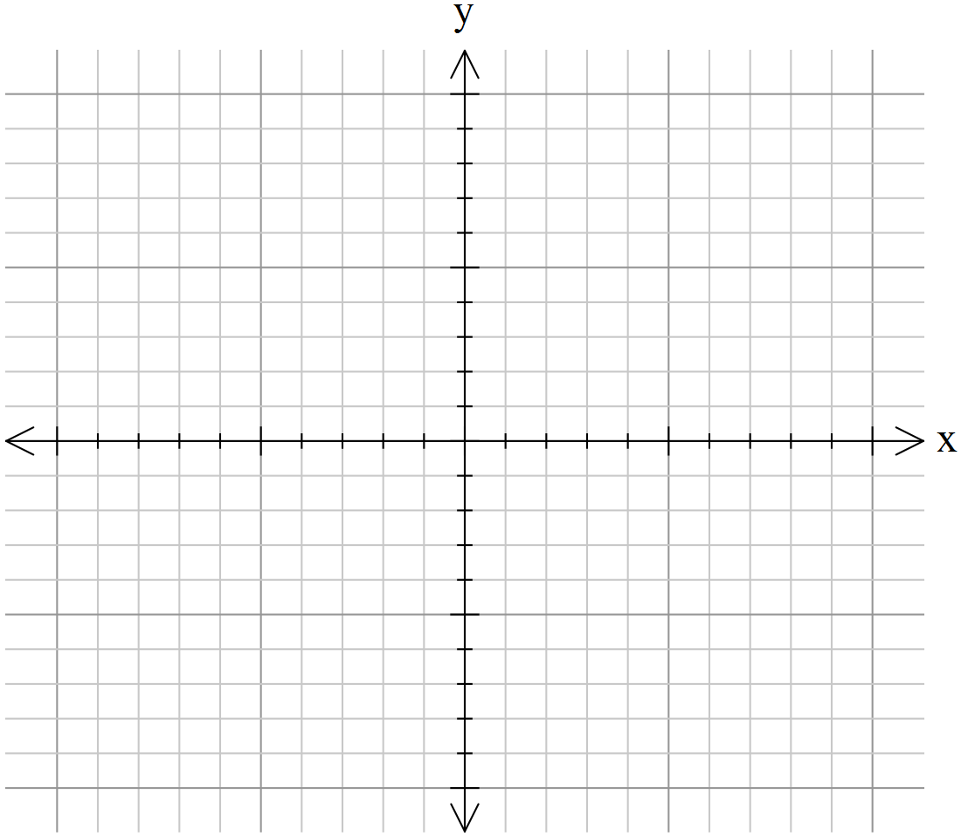

4. [4, 1, 2 = 7marks]
x | + | 3y | - | z | = | 5
2x | + | 7y | - | 3z | = | 6
-x | - | y | + | (p²-p-1)z | = | p-13
For what value of p will the above system of equations have:
- an infinite number of solutions,

- no solutions

- a unique solution?

END OF PAPER



West Coast Collaborative
Specialist Mathematics Units 3 & 4
Test 3 2018
Calculator Assumed Section
Name: _______________________ Score: _____ / 33
Time Allowed: 33 minutes Total Marks: 33
Materials Allowed: SCSA formula booklet, SCSA approved calculators and one A4 page of notes (both sides).
Instructions: Where a question or part of a question is worth more than 2 marks sufficient working to justify your solution is required.

5. [1,1,3,4 = 9 marks ]
The Cartesian equation of plane ∏ is .
a) State a vector equation of this plane.

The parametric equations of line are .
b) State a vector equation for line .

c) Determine the position vector of , the point of intersection of line and the plane.

d) Determine the acute angle between Line L and plane ∏ to the nearest tenth of a degree.

6. [ 5,3,4 = 12 marks]
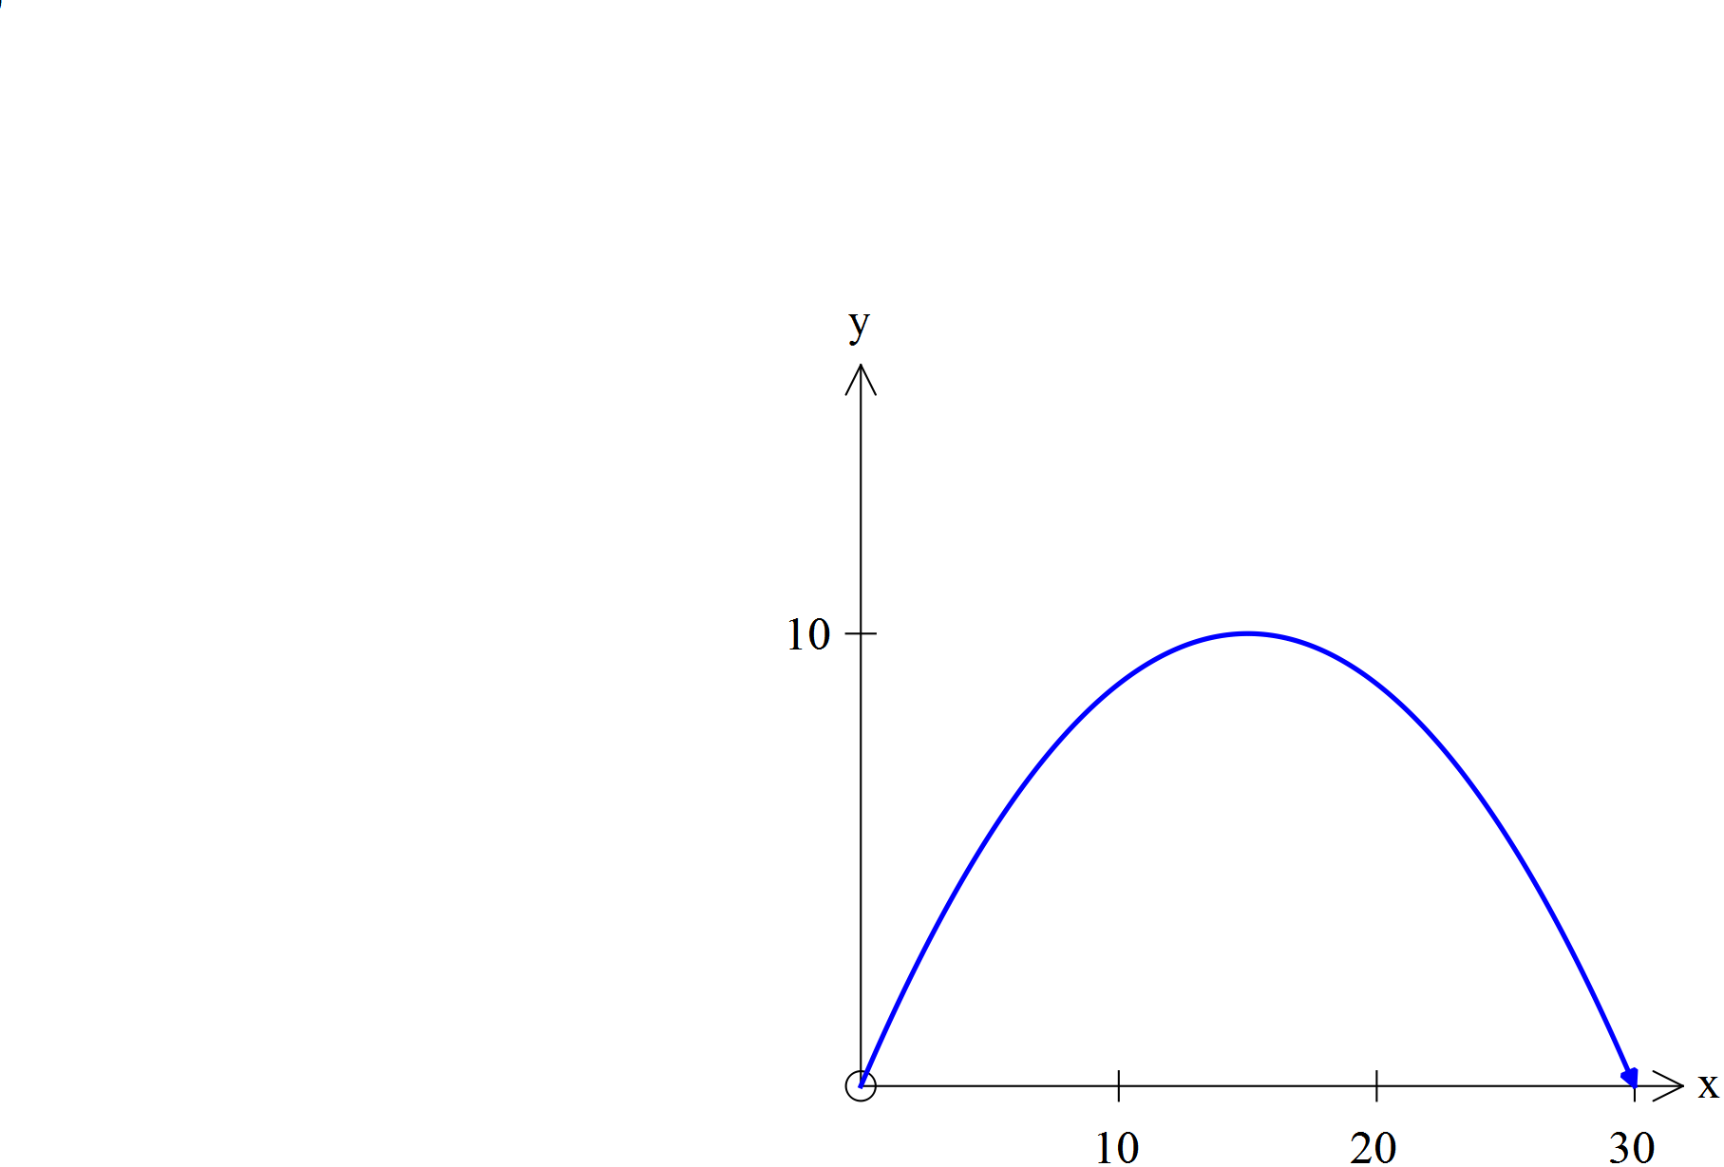For a particle projected from the Origin with speed µ ms⁻¹ at an angle of $0<θ^{°} <90$ with the positive x-axis, the position vector at time $t$seconds is $r\left(t\right)=ucosθti+\left(usinθt-5t^{2}\right)j$ metres. The equation of the path of the particle is given by

$y=xtanθ-\left[\frac{5(1+\tan^{2}θ}{u^{2}}\right]x^{2}$

The diagram featured shows the path of the particle.

The equation of the path of P is $=\frac{4x}{3}-\frac{2x^{2}}{45}$ .

a) State the position vector of P at time $t$ seconds.

b) Use vector methods to find the direction of the particle at time $t=1$seconds .

c) Use vector methods to find the distance travelled by P along its path, from the time of the projection to the time it hits the $x$-axis again. Show clearly how you obtained your answer.

7. [ 4 marks ]
Prove that the line r =$〈3,0,2〉+λ〈2,2,-1〉$ is a tangent to the sphere with equation (x-2)²+(y-1)²+(z+1)² = 10.

8. [ 2,2,2,2= 8 marks ]
Three particles A, B & C are such that their initial positions relative to the Origin at a given time are < 0, -1, -2> m ,
< 4, 1, 6 > m and < -4, 1, -2> m respectively. Their constant velocities are < 1, 2, 2 >ms⁻¹, < -1, α, -2 > ms⁻¹ and
< 3, 1, β >ms⁻¹ , also respectively.
a) State the position vectors of each particle after t seconds

b) If these velocities are maintained all three will collide. Use vector methods to determine the values of α and β.

c) If these velocities are maintained only A and B will collide. Use vector methods to determine the possible values of α and β in this instance.

d) If these velocities are maintained only two of the three will collide. Use vector methods to determine the possible values of α and β in this instance.

END OF TEST

